MEDIA RELEASE – World Day of Prayer 2024

I Beg You … Bear with One Another in Love

The invitation is out for everyone - men, women, and children of all ages - to join the 2024 World Day of Prayer as we celebrate the theme “I beg you … bear with one another in love” based on Ephesians 4: 1-3. A committee of Christian women of Palestine have prepared the service this year. We are encouraged to reflect on the history and challenges faced by this area as citizens struggle for security, peace and independence as well as the efforts that women have made during changes in ruling influences over the last century. This is an opportunity to examine a geographical area that is home to the birth of Christianity.

World Day of Prayer is an international, inter-church event that began around 100 years ago bridging social, geographic, and political barriers in 146 countries. Together we pursue justice, peace, and reconciliation by standing together in prayer and action.

Preparation for the day is vast. An international committee is based in New York and there are national committees and organizations in each participating country. In Canada, the World Day of Prayer (WDP) is coordinated by the Women’s Inter-Church Council of Canada (WICC), one of the original founders of this prayer movement.
Offerings received through the World Day of Prayer transform our prayers into action in the form of project grants empowering women and children in Canada and throughout the world. All regions share in the grants, with consideration given to greatest need. Through WDP offerings, WICC has distributed around 3 million dollars for small projects in the past 40 years. The vision is to restore hope to women and children touched by injustice.
The Women’s Inter-Church Council of Canada (WICC) invites you, your friends and family to join a service in over 1000 Canadian communities on or near Friday March 1, 2024. These may take place via Zoom or in-person. As well, individuals and families are welcome to watch a fifty-five-minute WDP service video prepared by WICC that features participants from across Canada. This video will be available on wicc.org as of February 1, 2024.

The SECTION below is to be COMPLETED by LOCAL ORGANIZERS of WDP services.

A local World Day of Prayer service will be hosted by Turin United Church Women on Friday, March 1, 2024 at 2:00 p.m. at Turin United Church, 14188 Turin Line, Thamesville

For more information, please contact:
Beth Gladstone at 519-678-3756 or Judy Clark at 519-678-3661

To learn more about WICC, please go to wicc.org or call 416.929.5184 or email wicc@wicc.org. Mailing address: 47 Queen’s Park Cres E., Toronto, ON M5S 2C3

Middle East
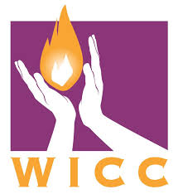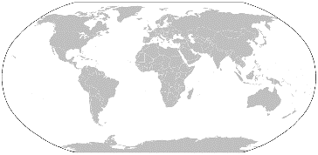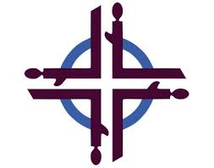
This Photo by Unknown Author is licensed under CC BY-SA

