St. Paul’s Affirming Journey
It was in 2016 that we began informal discussion about the possibility of becoming an Affirming congregation
We had been fortunate in developing a relationship with Victoria Avenue United who were a very early Affirming Ministry and the first in southwestern Ontario. Their building had suffered irreparable structural damage and they were looking for a new home. St. Paul’s invited them to join us in worship and since December 2013 we’ve been two congregations worshipping side by side.
Victoria Avenue’s affirming example encouraged us in 2017 at our annual meeting to commit to begin investigating the possibility of becoming an affirming and inclusive congregation. Shortly after that we established a committee to guide this effort in our congregation. After learning about available resources including Affirm United’s Open Hearts document and attending/supporting a few Chatham-Kent Pride events, we began a series of congregational gatherings.
In the first we reviewed again what it meant to be an affirming and inclusive congregation, learned more fully of Victoria Avenue’s experience in becoming affirming and were introduced to some of the challenges that members of the LGBTQ community experience and why the safe church community that we can provide is so important.
Following meetings engaged us in this conversation in different ways: presentations, group discussion, and the film “For the Bible Tells Me So”
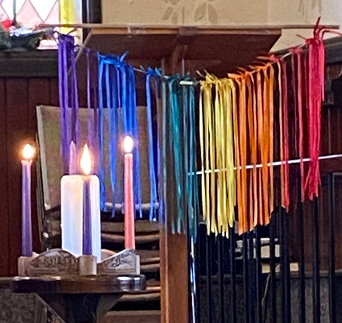
To keep the affirming vision in front of the congregation we introduced an Open Hearts Moment at the very beginning of each church service in which a member offered either an inclusive quote or a personal comment, and then tied a coloured ribbon onto what in time became a rainbow in front of the lectern.
For example:
“We all should know that diversity makes for a rich tapestry, and we must understand that all the threads of the tapestry are equal in value no matter what their colour. - Maya Angelou
“Isn't it amazing that we are all made in God's image, and yet there is so much diversity among his people?” - Desmond Tutu
In the spring of 2019, in partnership with St. Andrew’s United, we organized 3 events for our congregations and any others across Kent Presbytery who wished to join us.
A three part series examining how our community has changed over the past few years, and what more we can do to make our LGBTQ members feel safe and welcome.
The three evenings focussed on Our Youth, Our Community and Our Churches
Our Youth
Speakers: Dr. Ian Johnston, Consultant Pediatrician, Chatham-Kent Child and Adolescent Clinic
Ian & Stephanie Kennedy, Educators
Sabrina Bos, Youth Activist / Gay Straight Alliance lead
Our Community
Speakers: Brock McGregor, Chatham-Kent Councillor
Marianne Willson, Past President of Chatham-Kent Pride
Our Churches
Speakers: Joyce Payne, Past President of London Conference
Rev. Michelle Down, Minister of Congregational Life, First-St. Andrew’s United Church
At our 2020 Annual Meeting it was agreed unanimously that St. Paul’s would become an Affirming Ministry. We initially planned for a celebration service in May of that year but have rescheduled that a few times due to Covid, hoping to host the service in-person.
We’re pleased to be able to finally do that now, at 2 p.m. on October 17.
You’re welcome to join us. A Zoom link will be available on request

